1. A paper clip and a note

   Description automatically generated with medium confidence
2. 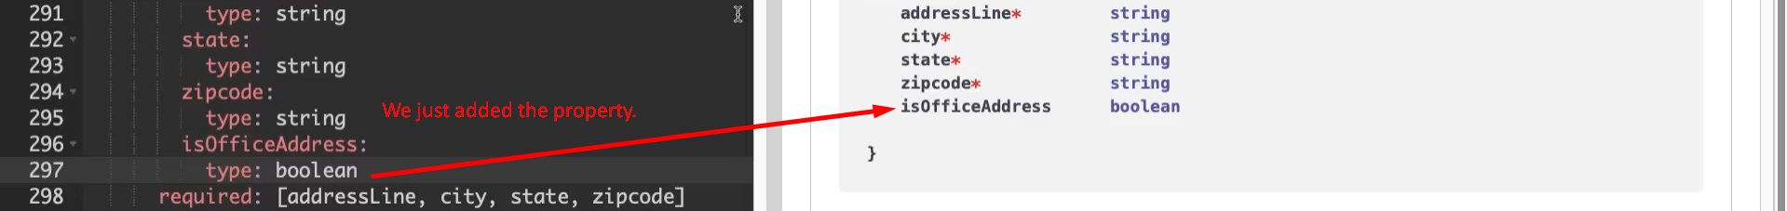
3. Let’s see in the example:  
   A screen shot of a computer screen

   Description automatically generated
4. Let’s define nullable  
   